Studded leather sandals
$70.00
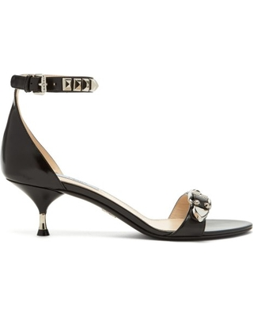

DETAILS
- Upper:Brushed leather
- 70% leather
- Embroidered logo

